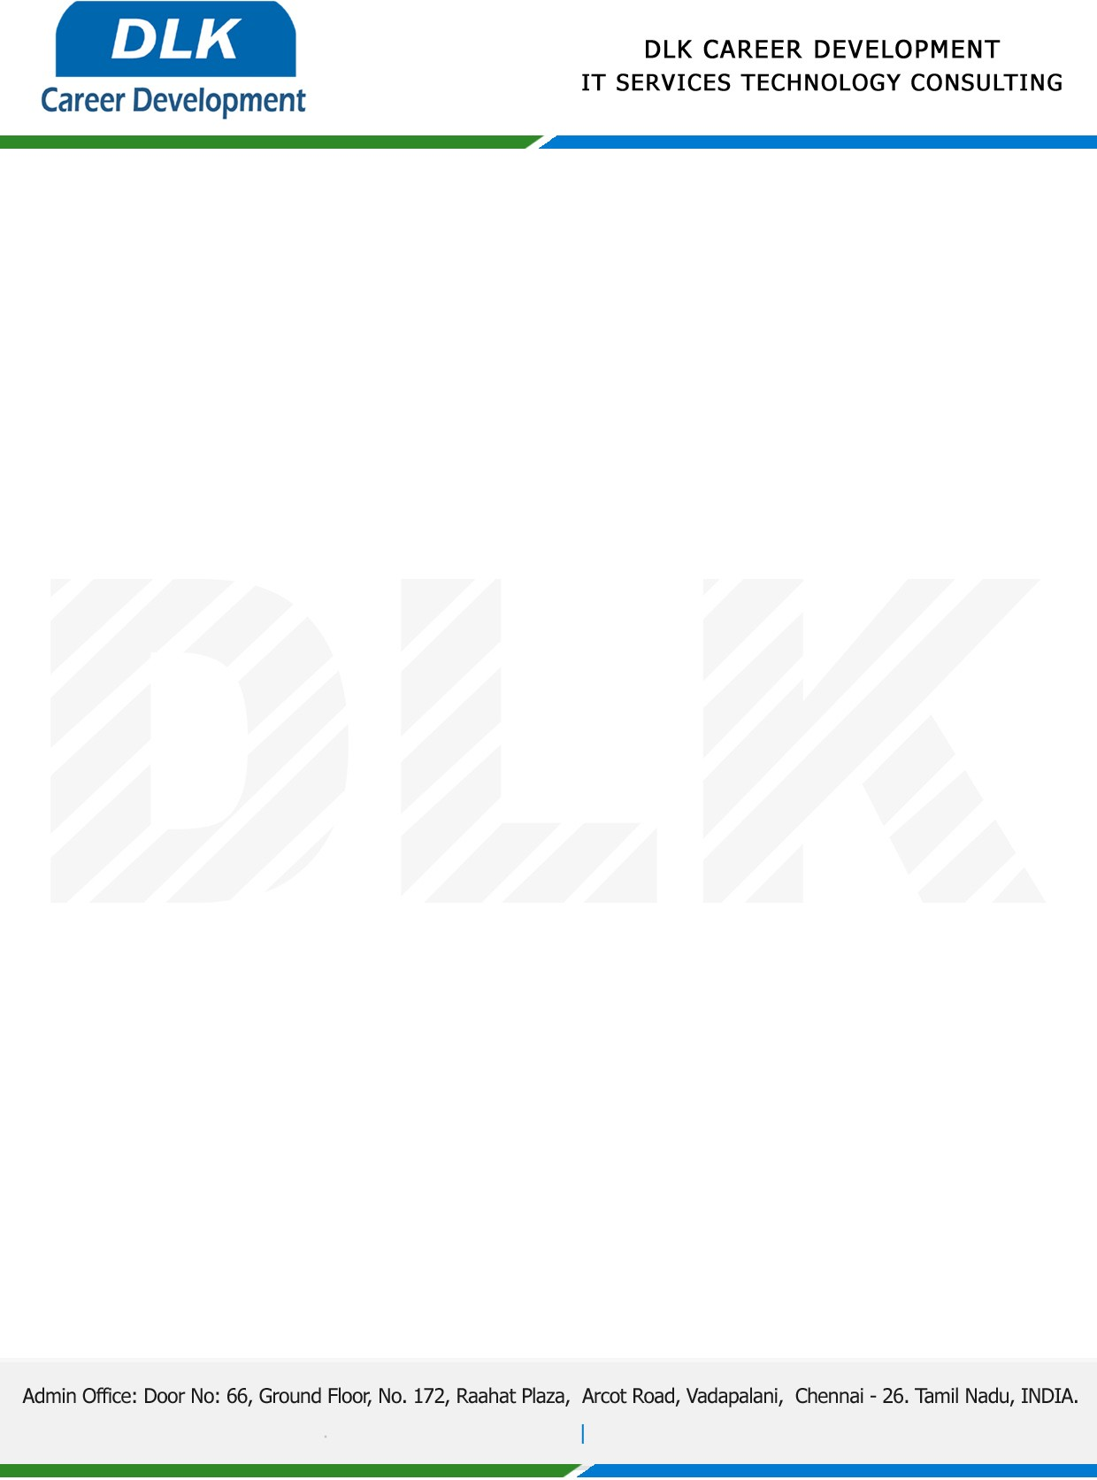

**Date: 25/April/ 2023**

**SUB: PROJECT COMPLETION CERTIFICATE**

This is to certify that **MR MELVIN RAHUL J (REG NO:** **RA2152007010011) MBA –Business Analytics,** final year student at **SRM Institute of Science and Technology, Chennai** has Successfully Completed his Project Work under the domain of “**PYTHON”** in our organization during the Period **(25th February 2023**

**to 24th April 2023)**

**Topic**: Doge coin Price Prediction Using Machine Learning

We appreciate your interest in **DLK CAREER DEVELOPMENT**

**“Best Wishes for Your Future Endeavors “**

